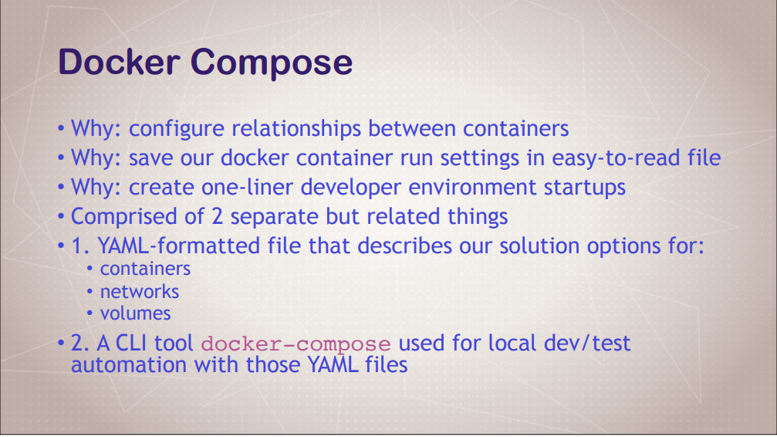

**Docker Compose**

Docker Compose is a tool that makes running multiple Docker containers much easier, than with Docker run commands

Structured way to contain normal common Docker commands and allow you to edit

Combinations of Command Line Tools and Configurations file

(Declarative – Create file with YAML commands and Imperative way - CLI)

Docker compose to replace run commands you are using over and over. Handles multiple containers at a time

**Multiple containers as a single service**

Tool for defining and running multi container docker apps

Using Yaml for configuration of compose services

You can start, stop and scale up docker compose services

Up: docker compose up (Spin up all of the services)

Stop: docker compose down (Tear it all down)

Logs: View all logs in a single stream

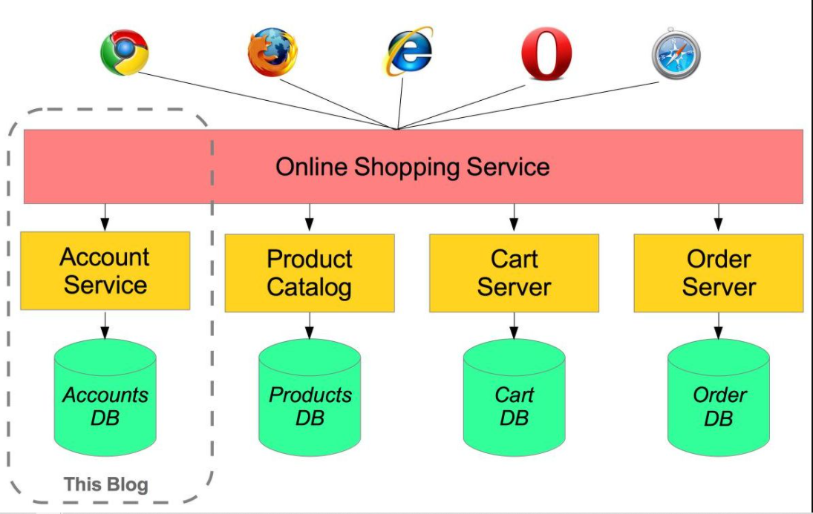

Install Docker Compose

curl -L "https://github.com/docker/compose/releases/download/1.24.0/docker-compose-$(uname -s)-$(uname -m)" -o /usr/local/bin/docker-compose

chmod +x /usr/local/bin/docker-compose

docker-compose version

*************************************************************************************

Create new directory

At new directory, create new file and name of the file is docker-compose.yml or docker-compose.yaml

Add below script at docker compose file

Using vi editor for creating file

‘vi docker-compose.yaml or vi docker-compose.yml

Refer notepad

Save and exit file from vi editor

Time for Run Docker compose file

Command for validate the syntax or validity of file by command

‘docker-compose config

**Get to know more about version, refer below web site**

Compose and Docker compatibility matrix

<https://docs.docker.com/compose/compose-file/>

Run / Execute / Up : Docker Compose is

‘docker-compose up -d

‘docker ps or docker-compose ps

-d indicates – De attached mode

Down – Docker Compose is

‘docker-compose down

**Want to incorporate Port number at Nginx server**

* Refer notepad

Up Docker Compose

‘docker-compose up -d

‘docker ps or docker-compose ps

‘docker-compose top

(Get formatted nice output)

‘docker -compose logs

After completion, create new browser where you supply

< Public DNS Value of instances or Public ip address: Port Number>

Example: http://ec2-54-226-71-49.compute-1.amazonaws.com:8095/

Down Docker Compose

‘docker-compose down

Scale up for container services

‘docker-compose up -d –scale database = 3

‘docker ps or docker-compose ps

‘docker-compose down

**Points to Remember**

You can create custom docker compose file without use of docker-compose.yaml.

Example, if your file is mongodb.yaml then how to apply docker compose is

‘docker-compose -f mongodb.yaml up -d (De attached mode)

Or

docker-compose -f mongodb.yaml up (Attached mode)

Down

docker-compose -f mongodb.yaml down